Networks need customers

David Leitch

2024-09-17

# Networks need customers

Australia chose the British system of electricity regulation as compared to the USA system. In the British view electricity supply consists of market facing elements, customers and generators and monopoly providers, that is the wires and poles, or in the gas of gas pipes.

In contrast by and large the USA system provides some regulatory oversight on the entirety of the vertically integrated business and the wires and poles are treated as part of the same business as generation.

As best put by Bruce Mountain this has therefore meant that the network customer is the regulator, in Australia the AER and the rules are more or less determined by the AEMC.

Every system has its strengths and weaknesses. From an IT point of view the separation means a lot of overlap between the network which sees a meter and a retailer that sees a customer. Networks don’t charge customers directly they charge the retailer supplying the customers. By and large as far as consumer electricity goes this means that the networks between see say 70% of their

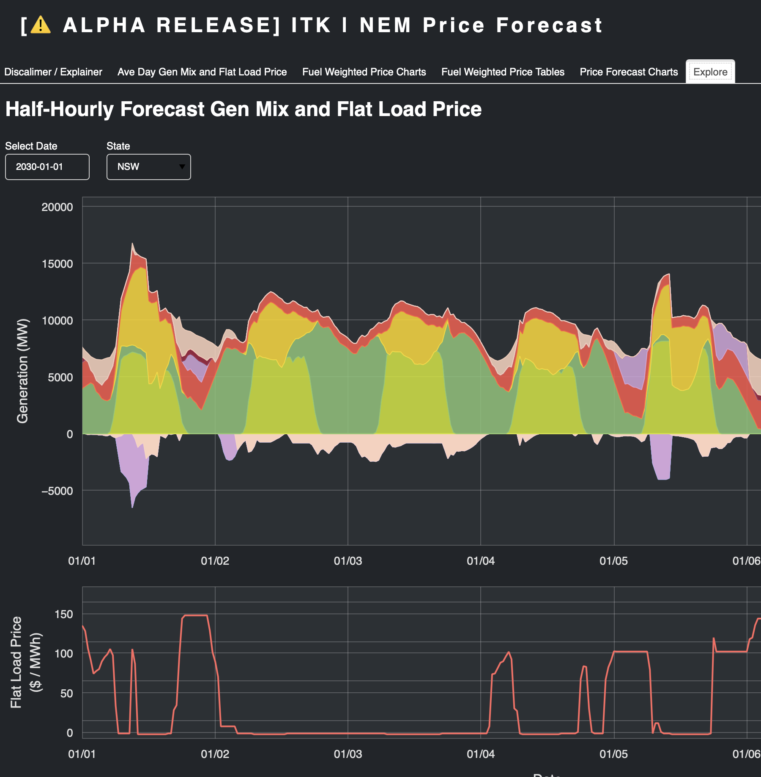

image-20240925094201791